1. Paines Creek
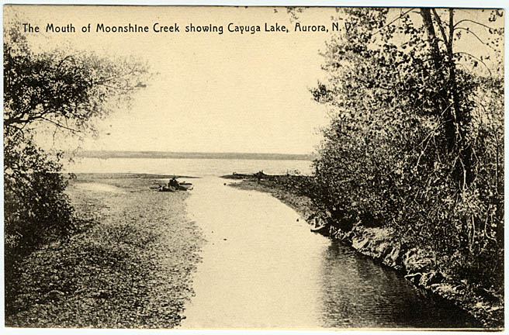

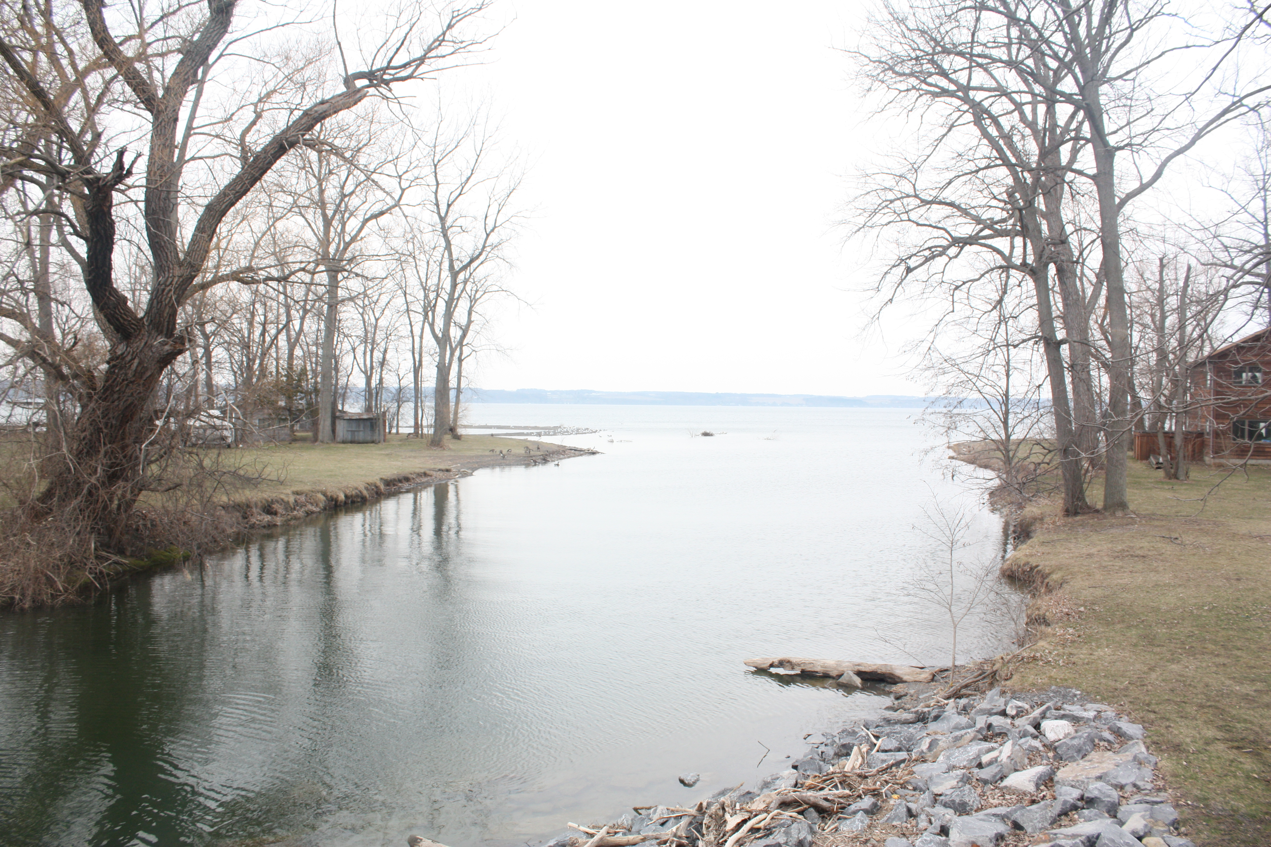

Paine's Creek: Paine's Creek is the small river located at the south end of Aurora that flows into Cayuga Lake. It was named for Edward Paine from Connecticut who built his log house on the creek shortly after 1791. A New York State historical marker indicates that the creek was been given the nickname “Moonshine Creek” because of the placement of Moonshine Falls, located one mile upstream. Further upstream, early saw, grist and woolen mills were located along the creek.

Written by Holly Signor

References:
List of New York State Historic Markers in Cayuga County, New York. New York State Museum. 23 July 2011. <http://www.nysm.nysed.gov/historicmarkers/hisaction.cfm>.
Hecht, William. Pictures of Cayuga County. Rootsweb. 12 April 2011.
<http://freepages.genealogy.rootsweb.ancestry.com/~springport/pictures_11/00001167.jpg>.
Current photo taken by Holly Signor, April, 2011.

