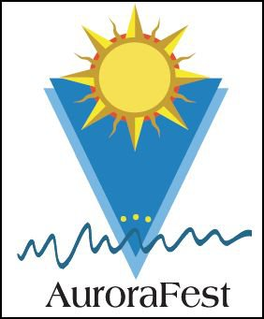
HEY!!! Tired of the cold? Want to get out of the house? Want to grab something to eat and have a few laughs? The Aurorafest Committee has the perfect solution…
AURORAFEST 2015
DISH TO PASS DINNER!!!
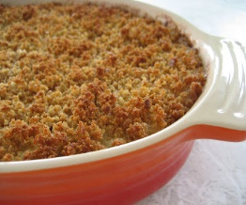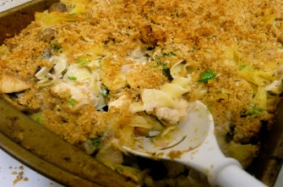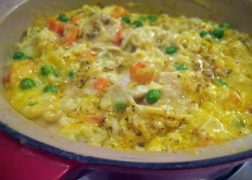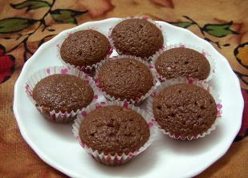
A GREAT WAY TO GET OUT OF THE HOUSE, SEE FRIENDS AND NEIGHBORS AND DINE ON GREAT FOOD!!!
Date: March 21, 2015 DOOR PRIZES!!!
Time: 6pm 50-50 Raffle!!!!
Place: Aurora Fire House Fun Surprises!!!
DON’T KNOW WHAT TO BRING?? A few ideas: Mac & cheese (everyone loves that), simple dessert (brownies, cupcakes), MAC & CHEESE, tossed salad, mac & cheese, green bean casserole, deviled eggs, tuna noodle casserole, mac & cheese, goulash mac & cheese, mac & cheese mac & cheese…..BRING YOUR OWN BEVERAGE
Paper supplies will be provided by the Aurorafest committee.
See you there!!!!
The Aurorafest Committee
Jeff Blum, John Wedler, Ann Balloni, Ginger Johnson, Pat Foser, Kit Van Orman, Michelle Miller, Becky Garbinsky

SAVE THE DATE: AURORAFEST IS JULY 11, 2015

